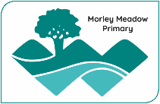 | Morley Meadow Primary School  Science Provision | 

Ask | INTENT  A scientist from Morley Meadow Primary School is learning to:  - Develop their substantive knowledge and conceptual understanding through the disciplines of Biology, Chemistry and Physics.  - Develop an enthusiasm and enjoyment of scientific learning and discovery.  - Develop an understanding of the nature, processes and methods of Science through different scientific enquiries that help them to answer questions about the world around them.  - Use a range of methods to experiment and communicate (disciplinary knowledge) their scientific information and present it in a systematic, scientific manner. Develop a respect for the materials and equipment they handle with regard to their own, and other children’s safety.
Aspire
Aspire | Teachers create a positive attitude to science learning within their classrooms and reinforce an expectation that all children are capable of achieving high standards in science. Our whole school approach to the teaching and learning of science involves the following;  - Science will be taught in planned and arranged by the class teacher structured around a whole school progression document.  - Through our planning, we involve working scientifically opportunities that allow children to find out for themselves. Children are encouraged to ask their own questions and be given opportunities to use their disciplinary and scientific knowledge to research to discover the answers. This curiosity is celebrated within the classroom. Planning involves teachers creating engaging lessons, high-quality resources to aid understanding of conceptual knowledge.  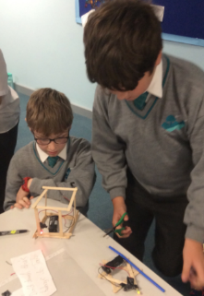  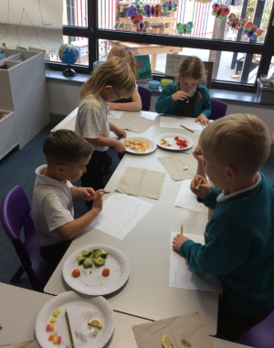  - Teachers use precise questioning in class to test conceptual knowledge, and assess children regularly to identify those children with gaps in learning, so that all children keep up.  - We build upon the learning and knowledge development of the previous years using the whole school progression document. As the children’s knowledge and understanding increases, and they become more proficient in selecting, using scientific equipment, collating and interpreting results (disciplinary knowledge); they also become increasingly confident in their growing ability to come to conclusions based on real evidence.  - Working Scientifically components are embedded into units through TAPS (Teacher Assessment Primary Science) activities, to allow the teacher to assess a learner’s disciplinary knowledge.  The National Curriculum provides a structure and component development for the science curriculum being taught throughout the school, which is now linked, where possible, to the Opening Worlds (History / Geography / RE) theme topics to provide a creative scheme of work, which reflects a balanced programme of study.  We endeavour to ensure that the Science curriculum we provide will give children the confidence and motivation to continue to further develop their knowledge into the next stage of their education and life experiences.  Substantive knowledge curriculum
Aspire | YF | Y1 | Y2 | Y3 | Y4 | Y5 | Y6
Aspire | In Early Years, Science will be taught through the children’s learning about the world around them in their education through play | Children in year 1 will be able to:  • name and describe a range of plants and animals;  • name parts of the human body;  • distinguish between objects and the materials that they are made from;  • describe the physical properties of some materials and describe seasonal changes noting how this effects the length of the day. | Children in year 2 will be able to:  • make associations between animals and their habitats;  • describe simple food chain;  • discuss what plants and animals need to grow;  • identify and compare the suitability of some materials and discuss how changes to the shape of some solids can occur through manipulation. | Children in year 3 will be able to:  • explain how water is transported in plants;  • explore the part that flowers play in the life cycle of a flowering plant;  • identify that humans and some plants have a skeleton;  • explain how humans maintain their health;  • compare and group different types of rock;  • have a simple understanding of how fossils are formed; | Children in year 4 will be able to:  •recognise that light is required to enable living things to see objects;  • observe and describe how magnets work;  • use classification keys to group living things in the local and wider environment;  • construct food chains;  • explain how the digestive system of a human works;  • observe that some materials can change state;  • identify how sounds are made and recognise how some components work in a simple electrical circuit. | Children in year 6 will be able to:  • describe differences in the life cycles and life processes of most living things;  • describe how humans develop;  • use evidence to discuss separation techniques for solids, liquids and gases;  • demonstrate an understanding of reversible and non-reversible changes;  • describe the relative movement of the Earth, sun and moon;  • identify the effects of gravity and friction  • investigate mechanisms that allow a small force to have a greater effect; | Children in year 6 will be able to:  • describe and explain how organisms (including micro-organisms) are classified;  • identify and name the main parts of the circulatory system;  • explain how water and nutrients are transported around the body;  • recognise how living things have adapted and changed over time, using evidence from fossils;  • explain how we see things  • give reasons for variations in the effectiveness of components in a simple electrical circuit.

Achieve | 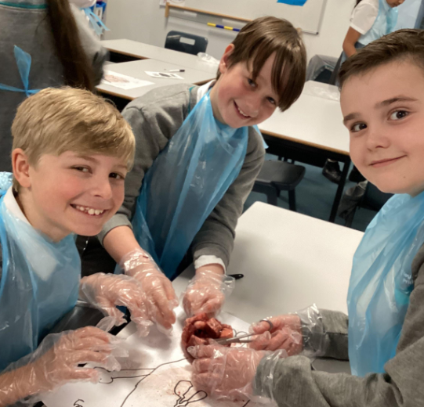  The successful approach results in a fun, engaging, high-quality science education, that provides children with the foundations for understanding the world. Our engagement with the local environment ensures that children learn through varied and first hand experiences of the world around them. To measure the achievement of our Science teaching, the following measures are taken into account:  • End of unit assessments which can be synoptic tasks, quizzes or closed tasks in order to assess substantive knowledge.  • TAPS assessments – these are completed three times a year and designed to support assessment and progression of disciplinary knowledge.  • Displays in each classroom (where appropriate) to support recall and celebrate knowledge.  • Audits have taken place of the science-curriculum and this is backed up by book looks and pupil voice.  • Pupil voice is used to further develop the Science curriculum, through questioning of pupil’s views and attitudes to Science to support the children’s enjoyment of science and to motivate learners.  • Children will receive an assessment of HNM (Has not met) or EXS (Expected) for their Science learning at the end of each year.  

