Morley Meadow Primary

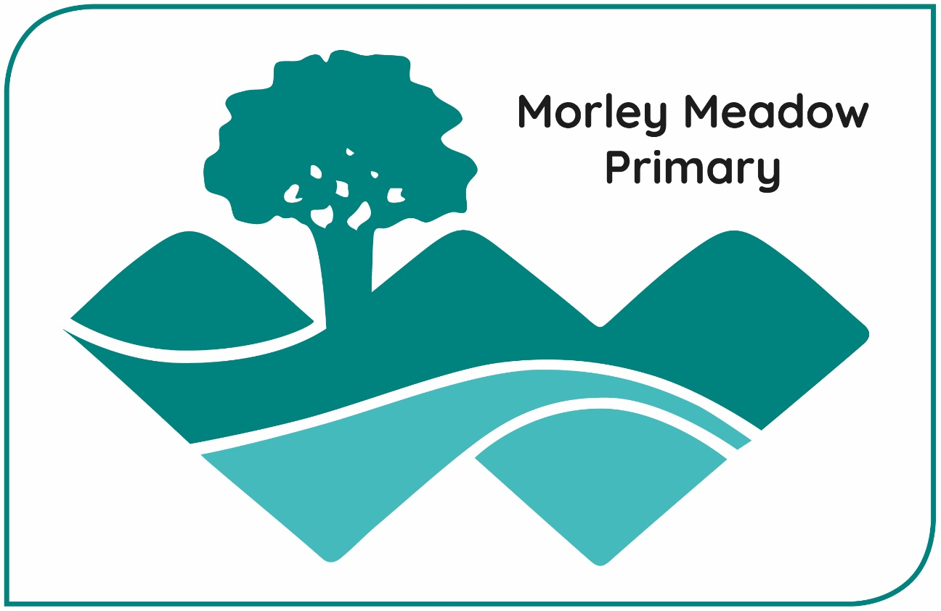
Ask, Aspire, Achieve

Parent Handbook
2025-2026


Dear Parents and Carers
A very warm welcome to Morley Meadow Primary and Nursery.
We are a single form entry school located in the heart of the Saltram Meadow estate in Plymstock. It is a privilege and an honour to be the first Head Teacher of this wonderful school, which opened in September 2021 following the relocation of Dunstone Primary School.
As proud members of the Westcountry Schools Trust, which consists of 23 primary and 8 secondary schools, we benefit greatly from collaboration across the Trust. This collective approach strengthens our school development and allows us to share expertise and best practice for the benefit of all our pupils.
Morley Meadow is a place where children feel valued, supported and inspired to learn. We believe that every child should have the opportunity to thrive, grow in confidence and develop a lifelong love of learning to Ask, Aspire and Achieve.
Our aim is to provide the highest quality teaching through a rich and stimulating curriculum. Our dedicated staff team works hard to ensure strong progress in core subjects while providing a broad, balanced and exciting range of learning experiences. We make excellent use of our outdoor spaces and wider local environment, helping children to explore, enquire and create lasting memories.
At Morley Meadow Primary and Nursery, where our nursery is teacher-led, we place great importance on building strong relationships and a sense of belonging with our children and their families. We believe that education is a true partnership between home and school, and we look forward to working alongside every family to make each child’s journey with us happy, fulfilling and successful.
If you have any further questions about anything outlined within this handbook, please do not hesitate to get in touch. We would welcome the opportunity to show you around our lovely school and share with you what we have to offer for your child.



Yours sincerely

Mrs Claire Duncan
Head Teacher

Contact Details

Telephone: 01752 401293
School Email: office@morleymeadowprimary.org.uk
Morley Meadow Primary,
51, Encombe Street,
Plymstock,
Plymouth
PL9 7GN

Staffing 2025-2026

Headteacher | Mrs Claire Duncan
Deputy Headteacher & SENCo | Mrs Rebecca John  (Maternity Leave Oct’25) | Acting DHT: Rob Oaten Acting SENDCo: Kate Stickley
Phase Leaders | Mr Rob Oaten, Mrs Vicky Bateson, Mrs Sarah Haddy
Buttercups | Mrs Kate Lyon, Mrs Rebecca Loze and Mrs Devon Pine
Snowdrops | Mrs Sarah Haddy, and Mrs Sue Deeley
Butterflies | Miss Evie Large, Mrs Claire Baker and Mrs Jennie Hewish
Ladybirds | Mrs Sophie Keylock Miss Molly Dannan and Miss Jordan Salt
Goldfinches | Mrs Vicky Bateson Mrs Angela May
Woodpeckers | Mrs Laura Thomas, Mrs Kate Stickley and Mrs Dawn Jarvis
Foxes | Miss Becca Short, Mrs Katie Hunt and Mrs Ros Tucker
Otters | Mr Rob Oaten and Mrs Cheryl Burton
HLTAs | Mrs Katie Sims & Mrs Cheryl Burton
Office Manager | Mrs Caroline Higgins
School Administrator | Mrs Susie Dannan
Nursery Administrator | Mrs Katie Sims
Family Support Advisor | Mrs Hannah Morgan
Caretaking | Mr Mike Graham
Lunchtime Support | Mrs Kirsty Smith, Mrs Angela May, Mrs Yuliia Matsiuta, Miss Jordan Salt, Mrs Sarah Rapson

Term Dates 2025-26
Autumn | Wednesday 3rd & 4th September  Friday 5th September  Friday 24th October  Monday 27th October  Monday 3rd November  Thursday 18th December  Friday 19th December | Non-Pupil Days  First Day of Term  Non-Pupil Day  Half Term  First Day of Term  Last Day of Term  Non-Pupil Day
Spring | Monday 5th January  Tuesday 6th January  Monday 16th February  Thursday 2nd April | Non-Pupil Day  First Day of Term  Half Term  Last Day of Term
Summer | Monday 20th April  Monday 25th May  Monday 1st June  Friday 26th June  Wednesday 22nd July | First Day of Term  Half Term  First Day of Term  Non Pupil Day  Last Day of Term

Safeguarding
If you have a concern about a child, or wish to talk, please speak to one of our Safeguarding Leaders.
Mrs Claire Duncan | Designated Safeguarding Lead
Mrs Rebecca John (Maternity Leave from Oct’25) | Deputy Designated Safeguarding Lead
Mr R Oaten | Deputy Designated Safeguarding Lead
Mrs Hannah Morgan | Deputy Designated Safeguarding Lead
Mrs Susie Dannan | Deputy Designated Safeguarding Lead
Mrs Sarah Haddy | Deputy Designated Safeguarding Lead
Mrs Katie Sims | Deputy Designated Safeguarding Lead

The school follows the guidelines laid down in Keeping Children Safe in Education 2025 and the Department of Health’s Working Together to Safeguard Children Guidance.

Academy
Morley Meadow Primary is part of Westcountry Schools Trust (WeST). For further information about the Westcountry Schools Trust and to visit the Trust's website please click here.

Admissions
Morley Meadow Primary and Nursery is a single form entry. This means we have one class per year group. The school has approximately 216 pupils from Nursery to Year 6. The school follows the Admissions Policy of the Local Authority (LA). Pupils are admitted to our Foundation (Reception) class in the September of the school year (1st September to 31st August) in which they will be five years of age.
The criteria for admissions in priority order are as follows:
- Looked After Children
- Children with exception medical or social grounds
- Children with a sibling already attending the school at the time of admission.
- Children whose parent/carer is a member of staff employed at the school
- Other children.

Welcome to School Arrangements
If it is necessary to distinguish between children in a particular category, priority will be determined on the basis of distance from the school measured by a straight line on the map – the shorter the distance, the higher the priority.
Before children start school for the first time, parents are invited to a meeting to share information. The children are then introduced gradually to school life, with half days attended during the first week, leading up to full time attendance. The Class teacher and Teaching Assistants make home visits as part of the induction process.

Assessment
The Education Reform Act requires schools to carry out a statutory assessment (SATs) through the National Curriculum tests in English and Maths at the ages of 7 and 11. Numerous other forms of assessment take place all of which provide the child and the teacher with information about where they are and what they need to do next. An annual report to parents is sent home every year and parents’ evenings are held twice a year, where you are invited to share and discuss your child’s learning and development.

Attendance
Morley Meadow Primary promotes the view that regular attendance is important to ensure the best possible learning outcomes for all our children. We feel that the whole school community takes responsibility for attendance. Parents and carers are required to contact the school office by phone or in person if their child needs to be absent from or late to school. Authorised absences include genuine illness, unavoidable medical/dental appointments, days of religious observance, and exceptional circumstances such as bereavement, or seeing a parent who is on leave from the armed forces. Medical appointments should always be arranged if possible outside the school day. Where this is not possible it is expected that pupils only miss part of the day. It is the Head Teacher, using DFE guidelines (Working Together to Improve School Attendance 2024) who makes the ultimate decision to authorise absence. The law does not grant parents the automatic right to take their child out of school during term time. Schools will only consider requests from a parent and absence will only be authorised in exceptional circumstances.

If the school refuses a request and the child is still taken out of school, this will be recorded as an unauthorised absence and may make a parent liable to a fine per parent, per child. All holiday requests must be made in writing to the head prior to the holiday being taken. Parents/carers can apply (in exceptional circumstances) for leave of absence by contacting the school for the appropriate form.

If any child has not been registered or the school has not been notified about a child’s absence, the office will contact the parent carer on the first morning. If an absence is unexplained it will be classified as unauthorised. Any absence considered not to be a justified reason will remain unauthorised. A series of unauthorised absences may trigger a referral to the E.W.O. (Education Welfare Officer).

School starts at 8:50 am, classroom doors open from 8:40 and the gates are locked at 8:50 which is the official start of the day. Lateness is classed as any child coming into school between 8:50 am and 9:10 am. All children arriving after 8:50 am must report to the office and be signed in by parent/carer for fire and evacuation purposes. At this point lunch arrangements must also be confirmed by the parent/carer. After 9:10 am it is classed as an unauthorised absence. Lateness is monitored. Where children have persistent lateness problems the head will invite the parents into school to a formal meeting.

Relationships
Strong relationships between staff and pupils are vital. At Morley Meadow Primary School, we believe that the most important aspect in children feeling valued, safe and secure is the sense of connection and trust with a member (or more than one member) of staff. Staff must be fair and consistent with children (taking into account individual needs). Children need to understand that the staff member is in control at all times, enabling pupils to feel safe. Equally, staff must be approachable, kind and be there to help and discipline (to teach and not punish) and children must understand and believe this. If a member of staff is having difficulties with an individual or group of children, they are expected to seek support in order to make a positive change.

Aims:
At Morley Meadow, we strive to:
- Have an inclusive, relational and kind school.
- Provide a safe, happy, friendly and respectful environment which encourages each individual to achieve their own potential through a desire for excellence
- Support children with their feelings and behaviour through providing children with strategies to manage their own feelings and behaviour.
- Maintain a calm and purposeful working atmosphere.
- Ensure that all children and adults have a sense of belonging, feeling safe, secure and valued
- Provide a clear, fair and consistent approach to behaviour.
- Foster, nurture and value strong and healthy relationships.
- Ensure that our children are intrinsically motivated to do the right thing because it is the right thing to do.

Everyday routines and expectations:
We expect every adult in our school community to:
- Meet and greet each child in their care
- Use the consistent language of ‘ready, respectful, safe’
- Model positive behaviours and build relationships
- Be calm when using stepped boundaries
- Follow up every time; retain ownership and engage in reflective dialogue with children
- Never ignore or walk past children who are not behaving safely (stop, notice, remind, move on)
- Ensure that all children are placed on the Recognition Board
…so that children are ‘ready, respectful and safe’
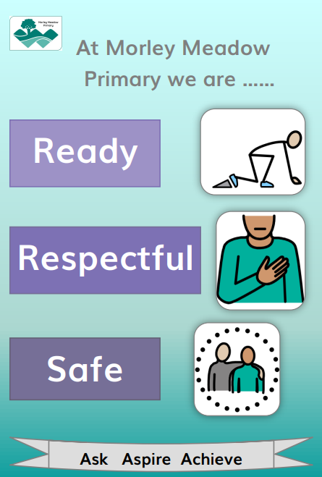

Recognition Strategies
At Morley Meadow Primary school, the following positive strategies will be used by all adults in the school. They are designed to ensure ‘first attention goes to best conduct’ and to create clear, simple routines and expectations that make children feel valued members of our learning community and are motivated to always try their best.
All adults will be looking out for children who show Morley Meadow Primary School’s values and who go above and beyond. Some ways that children will be recognised for doing so are:
- Marbles in the Jar
- Postcards Home
- Celebration Assembly
- Hot chocolate Friday
- Headteacher Awards
- Sporting Achievement Awards
Boundaries for safe behaviour:
We understand that a common and consistent use of language around behaviour is essential in creating clear boundaries for learning how to behave. When behaviour is displayed that falls below our expectations, we will follow a stepped process.
Step 1: Reminder A reminder of the 3 simple rules: ready, respectful, safe
Step 2: Caution A clear caution, making the pupil aware of their behaviour and clear communication of the consequences if they continue.
Step 3: Last Chance A final opportunity to engage
Step 4: Reflection time A few minutes for the child to calm down, breathe and compose themselves. This may be in a different space.
Step 5: Repair A restorative conversation; this may be informal or a more formal discussion, depending on the needs of the child.
Children’s Records
Records are kept on each child. Information includes: Admission information, reports from outside agencies to which the child may have been referred e.g. Educational Psychologist and any information that might have been given by the parent. All records are kept securely wither in a locked cupboard or electronically. Please see the school website for our GDPR privacy statements.

Collective Worship
This is part of our school assemblies. Collective Worship at Morley Meadow Primary provides each child with a period for quiet reflection and physical calm. It should foster a sense of personal and social responsibility and become a focal point of the school.

Curriculum
Children in our Early Years, follow the 2021 Framework for the Early Years Foundation Stage. There are seven areas of learning, which are all equally important and interconnected. The three prime areas are:
* communication and language
* physical development; and
* personal, social and emotional development.

All Yr 1-6 children follow the National Curriculum subjects: English, Mathematics, Science, Computing, History, Geography, Art, Design and Technology, Music, Religious Education and Physical Education and at KS2 a modern foreign language (Spanish). Arrangements need to be made with the Head Teacher if parents wish to withdraw their child from Religious Education. Children start on the National Curriculum after the Foundation (Reception) year. At Foundation children follow the Early Years Foundation Stage (EYFS) Curriculum.

Educational Visits/Visitors
We feel that visits and visitors are particularly beneficial to all children. Educational visits and visitors will provide an opportunity to enhance and inspire children’s learning. You will be informed of activities by letter and monies will be collected via SchoolMoney to cover the charges incurred. For Year 4 and 6 children, residential visits are organised where possible. Such experiences are educationally worthwhile, and children gain from them socially whilst learning to be more independent. Detailed risk assessments are carried out. Your consent will be sought for visits that include foreseeable risks. Whilst it is our wish to take all children, we reserve the right to refuse any child who is for any reason likely to cause harm to himself/herself or anyone else and any child who requires a disproportionate amount of individualised adult supervision.
Details and costs are sent out beforehand. Consent forms are collected for all trips when your child starts the school. Most visits are funded by parental voluntary contributions and in the event of a significant shortfall of contribution the visit will be cancelled. We also encourage many varied visits to school by outside speakers and groups or theatre companies.

Equal Opportunities
It is our policy that training will be given to our staff to overcome discrimination. This includes ensuring all staff are fully aware of their responsibilities towards the promotion of equal opportunities, racial and sexual equality and that they will be properly equipped to take account of the different and special needs of particular groups and thus make provision for those needs.

Extra-Curricular Activities
Children have the opportunity to take part in a range of activities during the mid-day break and after school. Details of the clubs operating will be sent home at the beginning of each term. We would welcome offers from parents to run interest/activity clubs, particularly if they are qualified or experienced in their particular area of leisure pursuit. An enhanced DBS check would be required for any volunteer helpers. If a child is attending an after school club or is representing the school, a permission slip is required.

First Aid
Should children need first aid to be administered, staff act in ‘loco parentis’ (as caring parents) and follow school procedures. If there is concern about an injury, the child is referred to our qualified first aiders. who decide the action that needs to be taken. All first aid applied is recorded in our school accident book and the child may be given a slip to inform the parent and alert them to any possible delayed reaction. If a child receives a minor bump to the head parents will receive a text. Injuries that we deem serious will be reported to the parents/carers immediately. It is therefore essential that we have two contact numbers for parents or carers during the day.

Health and Safety
Sometimes children have head infestations (head lice). In which case, a text is sent to all children in the class and parents are informed in confidence if it observed that their child has the problem. If head lice are ‘live’, parents are contacted to take their child home to apply treatment, so that we can hopefully avoid the problem spreading. Staff may notice head lice on the surface of children’s hair and around the collar and may monitor recurrences. This is of course done discretely, and parents are informed if the head infestation is present.

Occasionally, young children have ‘accidents’ due to not making it to the toilet in time. If garments are wet, we provide clean clothing, which the child changes into. Should a child be unwell, or clothing is badly soiled, we will contact parents.

Parents are asked to park considerably outside the school and not use the staff car park during the start and end of the school day, for the safety of the children. There is a community car park outside of the school which can be used.
Dogs, except guide/hearing dogs are not allowed on the premises.
Morley Meadow Primary has in place a non-smoking policy, this includes e-cigarettes. Smoking is not permitted either in the building or anywhere in the grounds.
A copy of the Health and Safety Policy is available from the School Office or on the school website.

Home School Partnership
All schools are required to have an agreement which defines the vital roles, responsibilities and expectations of all those involved, enabling an effective partnership for the benefit of all the children.

Inclusion Opportunities
At Morley Meadow Primary, we welcome all children. Where a child has a recognised disability, we will make all reasonable adjustments to accommodate their needs in school. This will include the availability of resources and accessibility of the school building and site. We will make every effort to ensure that children with Special Educational Needs maintain their entitlement when they enter the school. The school’s Special Educational Needs co-ordinator is Mrs.

Lunch
School meals are prepared in our kitchen and served in the multi-use hall. Children have a choice of menu both with main course and dessert and a vegetarian option is always available. Children are encouraged to make healthy choices and information posters are displayed around the dining area to reinforce this message. A drink of milk or juice is served with meals. Packed lunch children must bring in their own drinks, but not fizzy or highly coloured drinks please. Lunch money must be paid in ADVANCE using the online payments system. The school does not accept cash for school lunches. All Foundation and Key Stage 1 (Years 1 & 2) children are currently entitled to a universal free school meal. Free school meals are supplied to children whose parents are in receipt of Income Based Job Seekers Allowance or Child Tax Credit, with no Working Tax Credit and an annual income not exceeding £16,190. Further information is available from the school office. Children may bring a packed lunch if they prefer, but all containers for food and drink must be ‘non-breakable’ and clearly named.

Medication
We are able to administer medicines which are prescribed by a doctor and need to be taken more than twice, the treatment of asthmatic or similar conditions and other medication at the discretion of the Head Teacher.
Such requests need to be made to the School Office and a parental consent form completed. All medicines must be clearly labelled with the owner’s name, dosage details of when and how often it should be administered.

On sunny days we advise parents to apply sun cream before a child comes to school.

Morning Break
EYFS and Key Stage 1 are provided with a free piece of fruit each day and cold water is available. Children may bring in fruit or other healthy snacks for their break, but sweets, highly flavoured crisps, chewing gum, biscuits and chocolate bars are not permitted, as these have an adverse effect on children’s concentration and behaviour. We encourage children to be ‘healthy eaters’ and seek parents’ support with this.

Outdoor Learning
At Morley Meadow Primary we believe that play is very important to children’s learning. It helps them interact with the world around them and that making time for play in outdoor sessions is important. We understand that play is a central part of the essence of a child’s life and is important for their physical and social and emotional well-being.
There are many theories, ideas and methods about teaching children. There are however three main ways that children take in information on which they base their learning experiences. They are visually, what the child can see and what they are shown, auditory, what the child can hear and what they are told and kinaesthetically, what the child can experience through tactile learning and doing. ‘Wild Tribe’ activities are taught to the children and facilitate the experience of ‘doing’ and learning through the outdoors. We aim for outdoor learning to take place as much as is practicable, across all ages and across all areas of the curriculum.

Organisation
At Morley Meadow Primary and Nursery, we cover 2 stages of the National Curriculum and the Early Years Foundation Stage.

Pre-School 3-4 years
Reception 4-5 years
Key Stage 1 (Years 1 and 2) 5-7 years
Key Stage 2 (Years 3, 4, 5 and 6) 7-11 years

Each class has a Teaching Assistant in the mornings and the school also welcomes, therapists and family support workers.

Parental Involvement
Our school has a group known as ‘The Friends of Morley Meadow School’ (FMMPS). We are always looking out for parents to help assist with fund raising events. For more information on how to help please contact the School Office.

All parents are encouraged to spend time at home with their children in school related activities; sharing home learning, reading, spelling, multiplication tables, research work and so on, with children provides encouragement and continuity to the learning process.

An enhanced DBS check will be required for all volunteer helpers.
The Head Teacher and staff are always pleased to meet parents before or preferably after school, to discuss their child’s progress and welfare. Problems can usually be resolved, and we request that if you have any concerns you let us know, at the earliest opportunity.

Photographs/Publicity
Parents/grandparents sometimes take photographs and videos of their children in school activities e.g. Celebration of Christmas and Class Assemblies for their own use only. On occasions we contact, or are requested by, media (newspaper, media, TV, School Website) for a school activity to be publicised. Such requests must always be approved by the parents through the photo consent form. If parents do not wish for their child to be in any such photograph/videos, this should be indicated on the photo consent form.

School Council
The School Council consists of 2 representatives from each class, who meet regularly. The meetings are chaired and minutes are taken. The children’s views and ideas are very important to us and their ideas are passed on to staff to be discussed and put into action.

Secondary Transfer
Children complete their primary education at the end of the school year in which they are 11. Parents may express a preference for a place at a local comprehensive school or elect for their child to take the 11+ selective procedures. Information is sent home in the Summer Term of Year 5 for preferences to be made in the Autumn Term of Year 6.
Information and support is given to the children and parents before they transfer and we work closely with both local comprehensive schools. Pre visits and inter-staff communication all helps to ensure a smooth transition.

Sex and Relationship Education
At Morley Meadow Primary we have introduced a whole school PSHE scheme called Jigsaw. Jigsaw combines PSHE, emotional literacy, mindfulness, social skills and spiritual development. An important part of the Jigsaw PSHE programme is delivered through the 'Relationships' and 'Changing Me' puzzle pieces which are covered in the summer term.
There are four main aims of teaching RSE:
• To enable children to understand and respect their bodies
• To help children develop positive and healthy relationships appropriate to their age and development
• To support children to have positive self-esteem and body image
• To empower them to be safe and safeguarded.

Each year group will be taught appropriate to their age and developmental stage. At no point will a child be taught something that is inappropriate; and if a question from a child arises and the teacher feels it would be inappropriate to answer, (for example, because of its mature or explicit nature), this information with be shared with you by your child’s class teacher. The question will not be answered to the child or class if it is outside the remit of that year group’s programme.

Special Needs
Children who have special needs are identified and assessed at an early stage. Specific support is provided in line with the Department of Education Code of Practice. This references five areas of special needs: communication and interaction; cognition and learning; behaviour; emotional and social development; sensory and or physical. The Code of Practice specifies two levels of support for children identified with special needs. The first is called SEN Support and involves providing something different or additional for a child, firstly within the classroom and secondly within the school. The emphasis is very much on increasing the range and variety of differentiation for the individual child. Education Health Care Plan (EHCP) is the second level of support and this involves providing something different or additional with substantial and additional support from external agencies (e.g. Educational Psychologists, Speech Therapist, Behaviour Support). Those pupils who have particular Special Educational Need are accommodated within their mainstream class with care taken to ensure that work is appropriate to their needs. The Local Authority’s Special Needs Support Services and Plymouth Psychology Service may be called upon to assist. At all times parents will be informed and involved.

Uniform
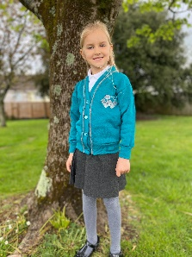
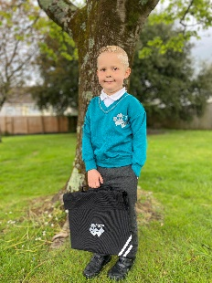
​​​
Foundation, Year 1 and Year 2
Jade V-Neck Sweatshirt with Grey Piping and Logo
Jade Cardigan with Grey Piping and Logo
White Polo Shirt (Polo shirt with logo is optional) ​​
Grey Trousers/Skirt/Pinafore (no black)
Black School Shoes (no trainers or boots)

Black Book Bag

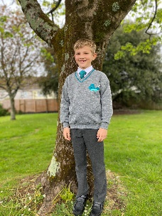
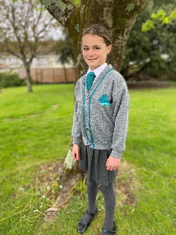
Years 3, 4, 5 and 6
Grey V-Neck Sweatshirt with Jade Piping and Logo
Grey Cardigan with Jade Piping and Logo
Tie Teal with Silver Stripe
White Shirt/Blouse
Grey Trousers/Skirt/Pinafore (no black)
Black School Shoes (all black, including the sole, leather look trainers will be permitted, no boots)

Small Rucksack (must fit in personal locker)
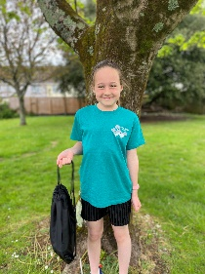
PE Kit
Jade PE T-Shirt
Black PE Shorts
Black Tracksuit/Jogging Bottoms (optional during cooler weather)
Plimsolls/Trainers Black

Optional Uniform
Softshell Jacket Black Fleece
Black Bottle Buddi (water bottle holder)
Cap with Logo Rio/Grey
PE Bag Jade/Black

All items with school logos can be ordered online from a local Plymouth company, The Uniform Company: https://theuniformco.co.uk/collections/morley-meadow-primary-school

Please name all clothing
- PE kit to be kept in small draw string bag
- Stud earrings only
- No toys or valuables
- Inexpensive watches are encouraged

Hair
Conventional hairstyles and natural colours only are acceptable. Grade 1 or 2 cuts or word shapes/patterns engraved into hair are not acceptable. Only small hair bands and ribbons are permitted.

Jewellery
Only watches (not smart watches) and stud earrings may be worn at school. On the grounds of safety, these must be removed for PE, games and swimming. These items (as with other personal belongings) remain the responsibility of the child at all times. Please do not let your child wear expensive items, as the school will not accept responsibility for loss or damage or injury. If a child is unable to remove ear studs for physical activities, then ears must be covered (e.g. with a plaster). Other than earrings, body piercing is not acceptable.

Second Hand Uniform
We have a selection of second-hand school wear which the FMMPS help manage. If you require any further information, please contact the school office.

Mobile Phones
Only children in Years 5 and 6 are permitted to bring mobile phones to school and MUST complete a mobile phone consent form before it is brought into school. The mobile must be handed in at the start of the school day and collected at the end of the school day from their class teacher. These are expensive items and the school insurance does not cover their replacement in the case of damage, loss or theft. The phones must be clearly labelled with the child’s name. We encourage parents to carefully consider whether their child needs to bring their mobile phone to school.

Computing
The school’s aims are to:
Provide a broad, balanced, challenging and enjoyable curriculum for all pupils.
- Develop pupil’s computational thinking skills that will benefit them throughout their lives.
- Meet the requirements of the national curriculum programmes of study for computing at Key Stage 1 and 2
- To respond to new developments in technology
- To equip pupils with the confidence and skills to use digital tools and technologies throughout their lives.
- To enhance and enrich learning in other areas of the curriculum using IT and computing.
- To develop the understanding of how to use computers and digital tools safely and responsibly

The National Curriculum for Computing aims to ensure that all pupils:
- can understand and apply the fundamental principles of computer science, including logic, algorithms, data representation, and communication
- can analyse problems in computational terms, and have repeated practical experience of writing computer programs in order to solve such problems
- can evaluate and apply information technology, including new or unfamiliar technologies, analytically to solve problems.
- are responsible, competent, confident and creative users of information and communication technology.

Rationale
The school believes that IT, computer science and digital literacy:
- are essential life skills necessary to fully participate in the modern digital world.
- allows children to become creators of digital content rather than simply consumers of it.
- provides access to a rich and varied source of information and content.
- communicates and presents information in new ways, which helps pupils understand, access and use it more readily.
- can motivate and enthuse pupils.
- offers opportunities for communication and collaboration through group working both inside and outside of school.
- has the flexibility to meet the individual needs and abilities of each pupil.

Security
We take security very seriously. As such:
- the computing technician will be responsible for regularly updating anti-virus software.
- use of IT and computing will be in line with the school’s ‘acceptable use policy’. All staff, volunteers and children must sign a copy of the schools AUP.
- parents will be made aware of the ‘acceptable use policy’ at school entry and KS2.
- all pupils and parents will be aware of the school rules for responsible use of IT and computing and the internet and will understand the consequence of any misuse.
- the agreed rules for safe and responsible use of IT and computing and the internet will be displayed in all computing areas.

Parental involvement
Parents are encouraged to support the implementation of IT and computing where possible by encouraging use of IT and computing skills at home for pleasure, through home-learning tasks and use of the school website. Parents will be made aware of issues surrounding e-safety and encouraged to promote this at home. The Safeguarding page on the school website has information for parents on online safety.

